**THE UNIVERSITY OF AUCKLAND**

|  |
| --- |
| **FIRST SEMESTER, 2020**  **Campus: City** |

**SOFTWARE ENGINEERING**

**Human Computer Interaction**

**(Time Allowed: TWO HOURS)**

|  |
| --- |
| Note:  **Submission timing.**  The final assessment will be released at 1pm June 18, 2020 and due after 24 hours at 12:59pm June 19, 2020. The final assessment is intended to be completed in two hours (115 minutes of working time plus 5 minutes allotted to scan items).  **Submission process.**  The final assessment questions (this document) will be delivered via a Microsoft Word file that can be downloaded and edited. There are three types of answer format.  Questions that require typed answers:   * Q1 * Q3.2, Q3.3, Q3.4   Questions that require an implementation answer:   * Q2   Questions that require a paper and pen/pencil answer:   * Q3.1   Students will need white paper, pencils and/or pens, an eraser. Students will use the *camscanner* app (or similar) to scan images. All typed and paper responses should be submitted as a combined PDF file. The implementation is submitted as an HTML file.  For each question and sub-question, state any assumptions that you have.  **Material covered.**  The final assessment is intended to be “*open-book*”, which includes all readings and lecture content from the course. Other online content is not needed for the test (apart from the files in Q2) and it is expected that students will not make use of any other online content during the test. Posting any test related material online is considered cheating.  **Communication during the assessment period.**  It is expected that students won’t communicate with each other or anyone else about the assessment during the testing period, thus students should not post questions on Piazza or elsewhere.  If you wish to raise concerns during the Final Assessment, please call the Contact Centre for advice: Auckland: 09 373 7513, Outside Auckland: 0800 61 62 63, International: +64 9 373 7513. The centre is open until 10pm NZST.  For any Canvas issues, please use 24/7 help on Canvas by chat or phone. [***Canvas Support Hotline***](https://canvas.auckland.ac.nz/)*: 0800 005 205*, [***Chat with Canvas Support (Students)***](https://cases.canvaslms.com/liveagentchat?chattype=student)*(Live chat with Canvas Support)*  If any corrections are made during the 24 hours, you will be notified by a Canvas Announcement. Please ensure your notifications are turned on during this period.  **Submission.**  Upload to Canvas as two files, an updated HTML file galleryStore08.html for Q2 and a single PDF file for all other answers.  It is your responsibility to ensure your assessment is successfully submitted on time. Please don’t leave it to the last minute to submit your assessment.  **Declaration.**  Please complete the declaration on p. 3. |
| **Question Format.**  There are three questions in this final assessment worth a total of 100 marks. You should answer all questions.  There are variations of Q3 based on the last digit of your Student ID. Answer the variation that corresponds to your Student ID as shown on the bottom left corner of your Student card (below). Incorrect matches to the digits of your ID will result in 0 marks.  Change in printing to reduce waste and improve efficiency - The ... |

|  |  |
| --- | --- |
| **Surname:** | **Burgess** |
| **Forename(s):** | **Aiden** |
| **Student ID:** | **600280511** |

Declaration

By submitting this assessment, you confirm that:

* You have completed this assessment with integrity and honesty and not committed any academic misconduct (i.e. cheating, plagiarism, assisting others to cheat or copy, engaging the use of third party assistance including from your fellow classmates, families or friends).
* Your submission represents your individual effort and does not contain plagiarised material.
* You are responsible to ensure that no one copies your assessment.
* You are responsible to fully comply with the **University’s Regulations, Statues and Guidelines** as stated and available at <http://www.auckland.ac.nz/uoa/home/about/teaching-learning/honesty/tl-uni-regs-statutes-guidelines>

By typing your name below, you acknowledge that you are fully aware and abide by the conditions stated above.

|  |  |
| --- | --- |
| **Date** | 18-06-2020 |
| **Surname** | Burgess |
| **Forenames** | Aiden |

**QUESTION 1: Visual Design [15 marks]**

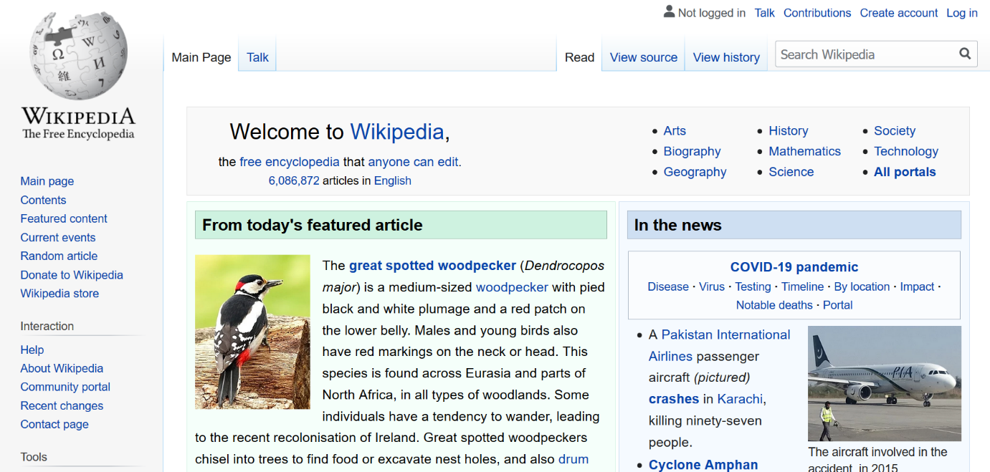

**QUESTION 2: Implementation [25 marks]**

Implement in the gallery page as given in the resource L15sampleStorage.zip the following functionality: double-clicking on any thumbnail moves that thumbnail to the last (rightmost) position of the filmstrip. Make this new ordering of the thumbnails persistent across browser sessions.

It is not important whether the large image is updated or not in this process.

Make only changes needed for this functionality and provide comments to your changes so that partial marks can be given in the case of any malfunction. Provide the solution as an updated HTML file galleryStore08.html.

**QUESTION 3: Usage Testing with Paper Prototype [60 marks]**

**Q3.1 Mid-Fidelity Paper Prototype** [25 marks]

Imagine that you are creating a specialised event ticket smartwatch app for a certain type of event and certain target audience. Answer Q3 for the type of event and audience indicated by the LAST DIGIT of your student ID in the table below:

|  |  |  |
| --- | --- | --- |
| **Last digit of Student ID** | **Event and target audience** | **Target user and one ‘other’ person** |
| 9 | Sport event | Senior who is 80 years old, who has a date |
| 8 | Visual art event |
| 7 | Book event |
| 6 | Theatre event |
| 5 | Cultural event |
| 4 | Sport event | Parent, aged 37, who has one child aged 5 |
| 3 | Visual art event |
| 2 | Book event |
| 1 | Theatre event |
| 0 | Cultural event |

Your prototype for Q3.1 should be done using pencil/pen and paper, which will be scanned into your submission. Use of digital tools for the prototype will result in 0 marks. You may use digital tools for annotation.

Write “Q3.1” and the last digit of your student number on paper beside your prototype.

Imagine the following “core scenario”: the target user has purchased two tickets for an event today: a ticket for themselves and one for the other person as indicated in the table above. The target user has also purchased tickets for three more events next week. The target user and other person have arrived at the event. The target user selects a ticket on their smartwatch using the specialised event ticket app. The selected ticket then shows a code (e.g., Fig. 1) that needs to be scanned when entering the event.



Figure 1. Example event ticket digital code that can be scanned when entering events.

By mid-fidelity, we mean that the screen elements should be relatively realistic (e.g., Fig. 2) and drawn with care. Design approximately three screens for a smartwatch screen size:

1. The main app screen that the user sees when initially tapping into the app, which should show all four ticket events.

The user then selects today’s event.

1. The screen shows today’s ticket selection.

The user then takes an action to display the code (Fig. 1).

1. The screen shows the code that needs to be scanned when entering an event.

 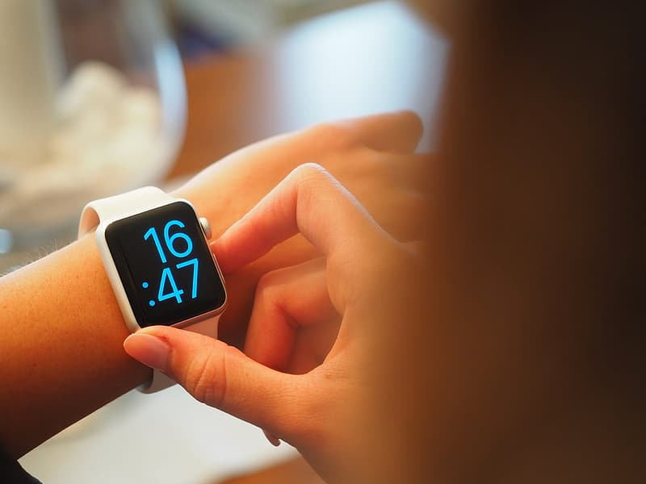

Figure 2. Example smartwatch screens

Images under license to use Creative Commons Zero - CC0: https://www.peakpx.com/478397/black-smart-watch https://www.peakpx.com/469136/grey-aluminum-case-white-sport-band-apple-watch

Include realistic and specific details of a scenario within your prototype by including specific event names and dates, etc. Annotate your paper prototype to justify

* its user experience,
* visual design principles that influenced the design, and
* its suitedness to the event type and target user.

**Q3.2 A Persona** [5 marks]

The answer to Q3.2 should be typed.

Create the start of a persona for the target user based on your student ID as above. The persona should have a name and goals and motivations. Write a maximum of three sentences for the goals and motivations. Do not use bullet points.

**Q3.3 Usage Testing** [20 marks]

The answer to Q3.3 should be typed.

Create a usage test task that evaluates the Q3.1 prototype screens a), b) and c).

Describe the hypothesis/ses and task. Include the exact “prompt” that the participant would read or hear. To fully understand the prompt, the participant may need additional explanation to understand what previous actions led to the current state of the interface. Include this background information.

Choose two quantitative metrics and two qualitative metrics for your usage test to ensure comprehensive coverage of user experience. Describe specifically how each will be measured, and include instructions needed for the collection of the data. Justify your choices for metrics.

A usage testing greeting and informed consent do not need to be included.

**Q3.4 Agile UX** [10 marks]

The answer to Q3.4 should be typed.

Describe how the usage testing would differ if it was following an Agile UX approach. Describe two example artifacts that could be included in Usage testing if it were done with an Agile UX approach, and describe how they would be included in the Usage testing. Answer in a maximum of 6 sentences.